# **Setting up WINTER-WINN database replication:**

**DB_MASTER_IP**: 192.680.48 (Ubuntu 20.4/pg12,

**DB_REPLICA_IP**: 192.680.57 (Raspberry Pi4, Buster/pg11),

## **1. Ensure the database on the replica machine is the same as the master machine. If not, use the following method to copy from master to replica.**

Method #1

Temporary change the DB settings pointing to the REPLICA machine. Then migrate

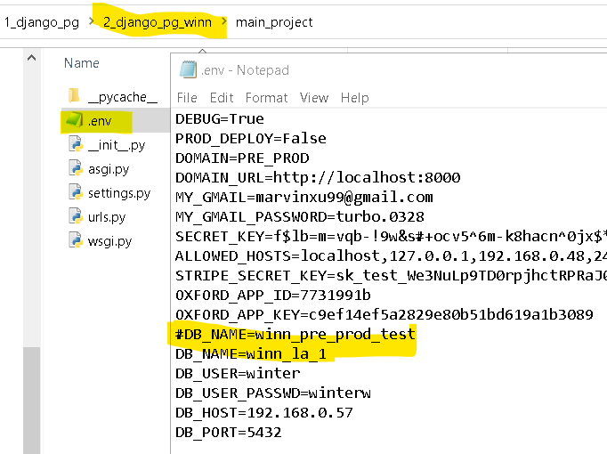

Method #2 – dump file copying

### **The most simple case is dumping and restoring on the same server:**

$ pg_dump -h **localhost** -Fc test > /home/postgres/dump.sql

$ pg_restore -h **localhost** test < /home/postgres/dump.sql

### **Or with a plain text dump:**

$ pg_dump -h **localhost** -f /home/postgres/dump.sql test

$ psql -h **localhost** -f /home/postgres/dump.sql test

1. Dump database winn_la_1 on DB_MASTER_IP to file winn_la_1.sql

$pg_dump -U postgres -h localhost -f winn_la_1.sql winn_la_1

1. **Copy the file winn_la_1.sql to DB_REPLICA_IP machine**
2. **On the DB_REPLICA_IP machine**

**$sudo -u postgres psql**

**#CREATE DATABASE winn_la_1;**

**# \q**$psql -h localhost -f winn_la_1.sql winn_la_1

$ *# dump a remote database to your local machine*

$ pg_dump -h **remotedb.mydomain.com** -f /home/postgres/dump.sql test

$ *# dump a local database and write to a remote machine*

$ pg_dump -h **remotedb.mydomain.com** test | ssh postgres@**remotedb.mydomain.com** 'cat > dump.sql'

$ *# dump a remote database and write to the same remote machine*

$ pg_dump -h **remotedb.mydomain.com** test | ssh postgres@**remotedb.mydomain.com** 'cat > dump.sql'

$ *# or a different remote machine*

$ pg_dump -h **remotedb1.mydomain.com** test | ssh postgres@**remotedb2.mydomain.com** 'cat > dump.sql'

## **Setting up publication on the Master machine**

$sudo -u postgres psql

# \c winn_la_1

# CREATE PUBLICATION winn_publication_all FOR ALL TABLES;

1. **Creating a subscription on the Replica machine**

$ sudo -u postgres psql

# \c winn_la_1

# CREATE SUBSCRIPTION pi_subscription CONNECTION 'host=192.168.0.48 port=5432 password=my_password user=sammy dbname=winn_la_1' PUBLICATION winn_publication_all;

1. On the replica machine (raspberry Pi), check if it is working by using:

$sudo tail -f /var/log/postgresql/postgresql-11-main.log

To check if the **replica** has connected to the **primary** and the **primary** is streaming, connect to the **primary** database cluster by running:

$ sudo -u postgres psql

# SELECT client_addr, state FROM pg_stat_replication;